ASSIGNMENT 18.4
Shaik Sabina 2303A51303BATCH – 05

TASK – 01
Prompt : Create a Python script using the requests library to fetch movie details from OMDb API.Requirements: Take movie title as user input, Fetch data from API using API key,Display: Title, Year, IMDb Rating, Plot,Handle
errors: invalid movie, API key issues, network errors, empty response,Use clean formatting and functions

Code :
#Create a Python script using the requests library to fetch movie details from OMDb API.
#Requirements: Take movie title as user input, Fetch data from API using API key,Display: Title, Year, IMDb Rating, Plot,Handle errors: invalid movie, API key issues, network errors, empty response,Use clean formatting and functions from gettext import install
import requests
def fetch_movie_details(movie_title, api_key):
url = f"http://www.omdbapi.com/?t={movie_title}&apikey={api_key}" try:
response = requests.get(url) response.raise_for_status() # Check for HTTP errors data = response.json()

if data['Response'] == 'False': print(f"Error: {data['Error']}") return

print(f"Title: {data.get('Title', 'N/A')}")
print(f"Year: {data.get('Year', 'N/A')}") print(f"IMDb Rating: {data.get('imdbRating', 'N/A')}") print(f"Plot: {data.get('Plot', 'N/A')}")

except requests.exceptions.RequestException as e: print(f"Network error: {e}")
except ValueError:
print("Error parsing response.") def main():
api_key = input("Enter your OMDb API key: ") movie_title = input("Enter the movie title: ")

fetch_movie_details(movie_title, api_key) if name == " main ":
main()

Output :
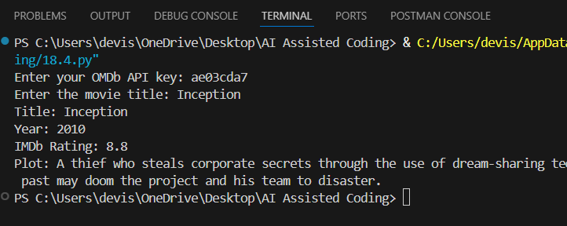
Explanation : This script allows users to fetch movie details from the OMDb API by entering a movie title and an API key. It uses the requests library to make an HTTP GET request to the API, retrieves the movie details in JSON
format, and displays the title, year, IMDb rating, and plot. The script also includes error handling for invalid movie titles, API key issues, network errors, and empty responses.

TASK – 02
Prompt : Create a Python script using the requests library to fetch public
transport arrival times from an API. Take stop ID as user input, validate it, and display the next 3 arrivals. Handle errors like invalid stop ID, server issues, timeout, and empty response using try-except. Include at least one retry attempt and keep the output clean and readable.
Code :
# Create a Python script using the requests library to fetch public transport arrival times from an API. Take stop ID as user input, validate it, and display the next 3 arrivals. Handle errors like invalid stop ID, server issues, timeout, and empty response using try-except. Include at least one retry attempt and keep the output clean and readable.
import requests import time

def fetch_arrival_times(stop_id, retries=1):
url = f"https://api.tfl.gov.uk/StopPoint/{stop_id}/Arrivals"

attempt = 0

while attempt <= retries: try:
response = requests.get(url, timeout=5) response.raise_for_status()

data = response.json()

# Check empty response if not data:
print("❌ No arrival data found for this stop.")
return

# Sort by soonest arrival
data.sort(key=lambda x: x.get("timeToStation", 0))

print(f"\n🚍 Next 3 arrivals for stop ID {stop_id}:") print("-" * 40)

for arrival in data[:3]:
line = arrival.get("lineName", "N/A")
destination = arrival.get("destinationName", "N/A") time_sec = arrival.get("timeToStation", 0)

minutes = time_sec // 60

print(f"Line {line} → {destination} in {minutes} min")

print("-" * 40) return

except requests.exceptions.Timeout: print("⏱️ Timeout error. Retrying...")
except requests.exceptions.ConnectionError: print("🌐 Connection error. Retrying...")
except requests.exceptions.HTTPError as http_err: print(f"❌ HTTP error: {http_err}")
return
except requests.exceptions.RequestException as e: print(f"⚠️ Error: {e}")
return

attempt += 1
time.sleep(2) # small delay before retry

print("❌ Failed after retrying.")

def main():
stop_id = input("Enter the stop ID: ").strip()

if not stop_id:
print("❌ Invalid stop ID.") return

fetch_arrival_times(stop_id)

if name == " main ": main()

Output :
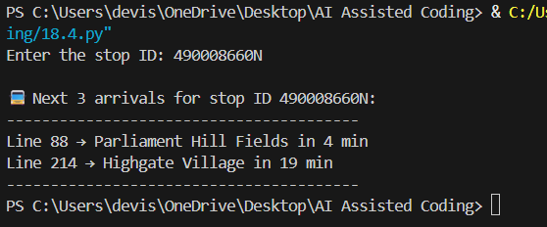
Explanation : The program takes a stop ID as input and fetches arrival data from the TfL API using the requests library.
It processes the response, sorts arrivals by nearest time, and displays the next 3 arrivals with details.
It also handles errors (timeout, connection, invalid data) and includes a retry mechanism for reliability.

TASK – 03
Prompt : Create a Python script using the requests library to fetch live stock
data from a financial API (such as Alpha Vantage). The program should accept a stock symbol as user input and display the current price, day high, and day low.
It must handle errors like invalid stock symbols, API rate limits, and missing fields in the JSON response. Ensure proper validation and safe parsing of the

API response using try-except blocks, and display clean, user-friendly output without any crashes.
Code :
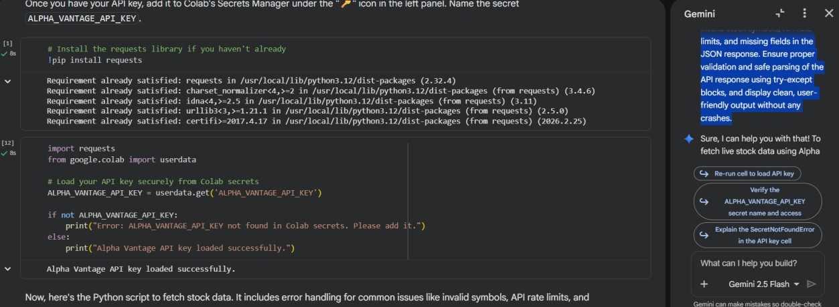
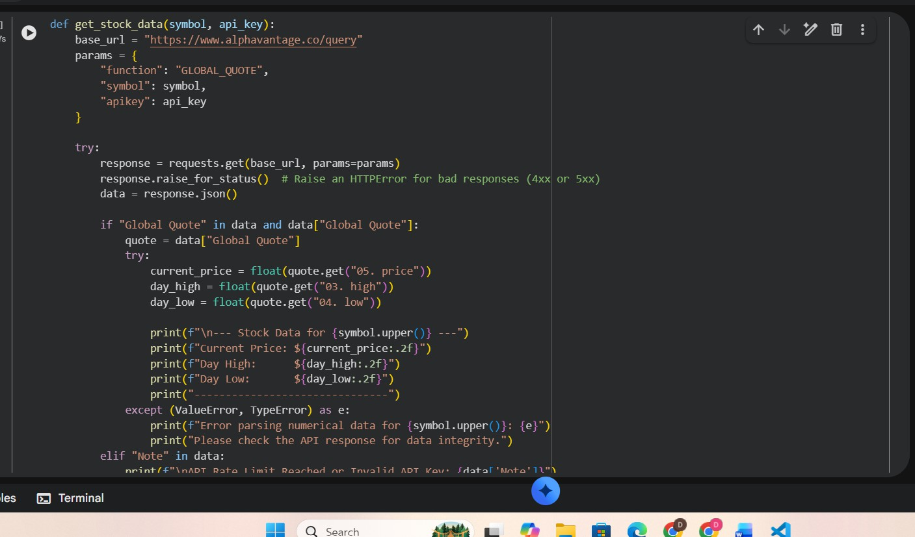

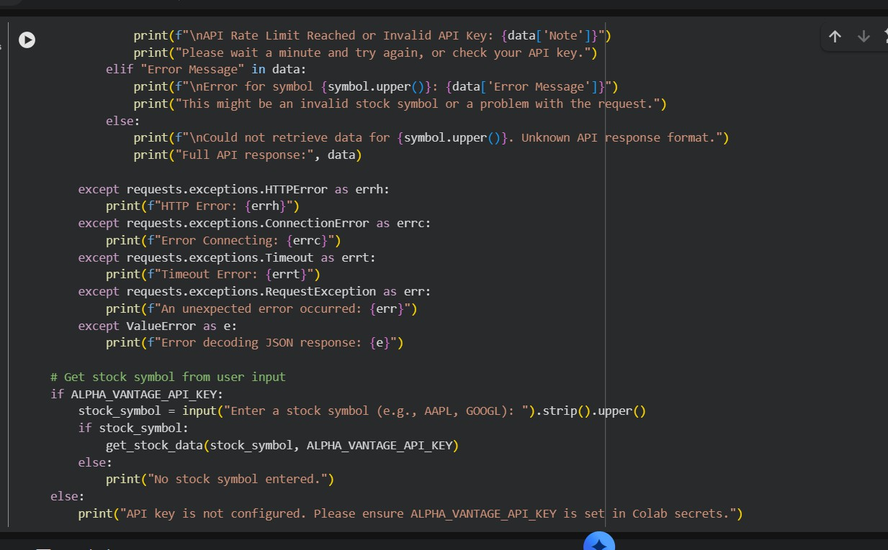
Output :
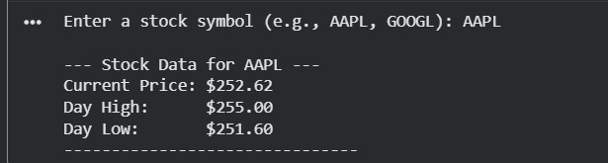
Explanation: The script takes a stock symbol as input and fetches its current price, day high, and day low from a financial API.
It safely handles errors like invalid symbols, rate limits, and missing data, ensuring clean output without crashes.

TASK – 04:
Prompt : Generate a Python script that takes an IP address as input, validates its format, and uses a Geolocation API (like ip-api.com) to fetch country, city, and ISP. Include error handling for invalid IPs, API failures, and JSON parsing issues, and display results clearly.
Code :

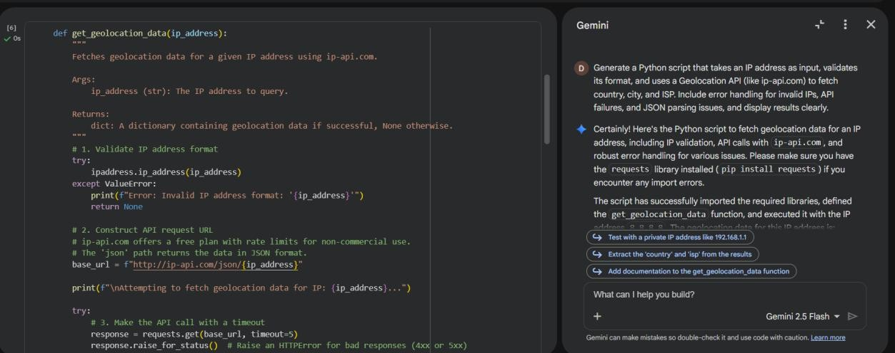
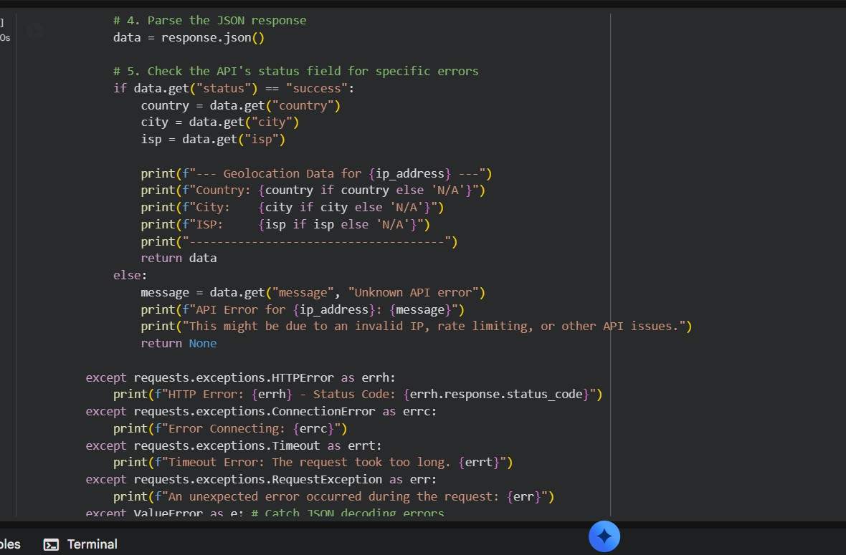
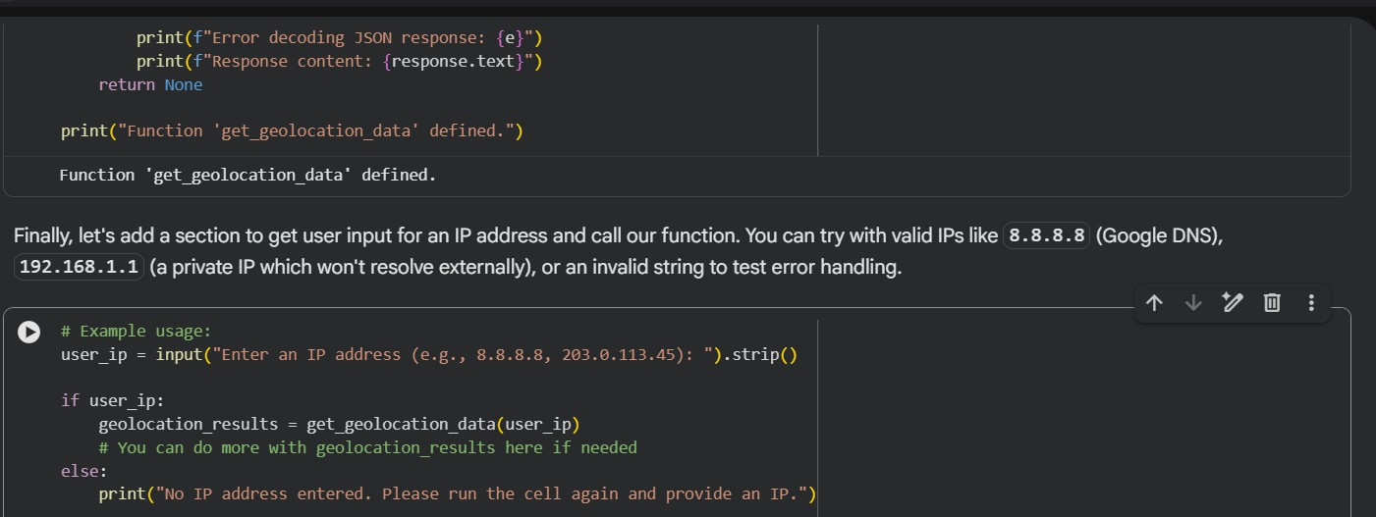

Output :

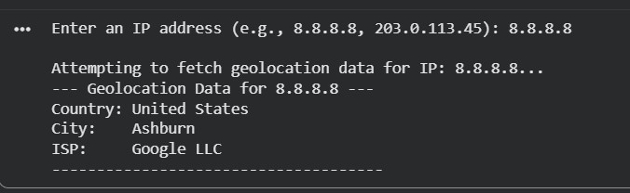
Explanation :
This script takes an IP address, checks if it is valid, and then calls a Geolocation API to get details like country, city, and ISP. It also handles errors such as invalid IP format, API failure, and incorrect JSON response to ensure the program runs safely.

TASK – 05
Prompt : Generate a Python script that simulates payment processing using a sandbox Payment API. It should send a POST request with amount, currency, and payment method, validate inputs, handle errors (invalid details, HTTP
errors, network issues), display transaction status, and log failed transactions to a file.
Code :
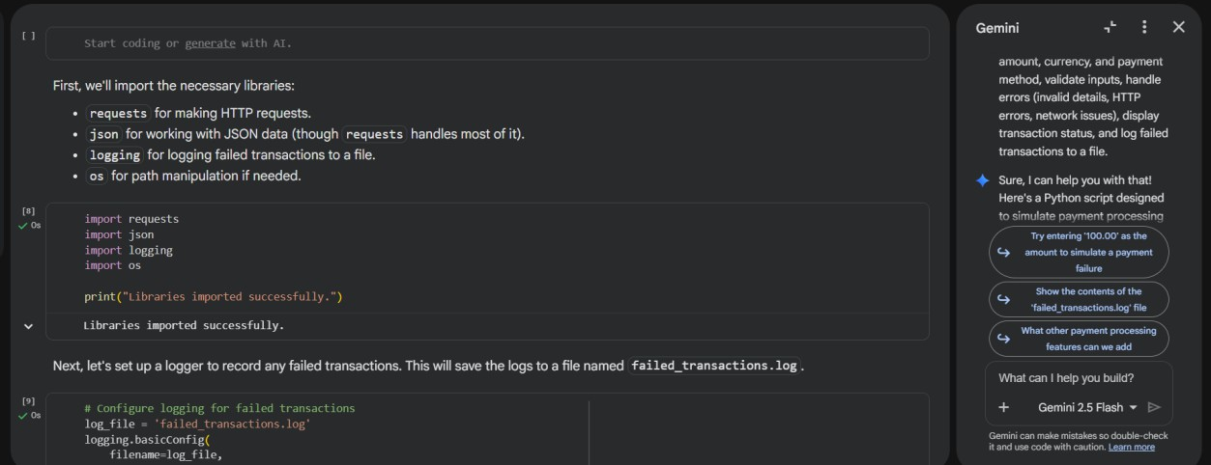

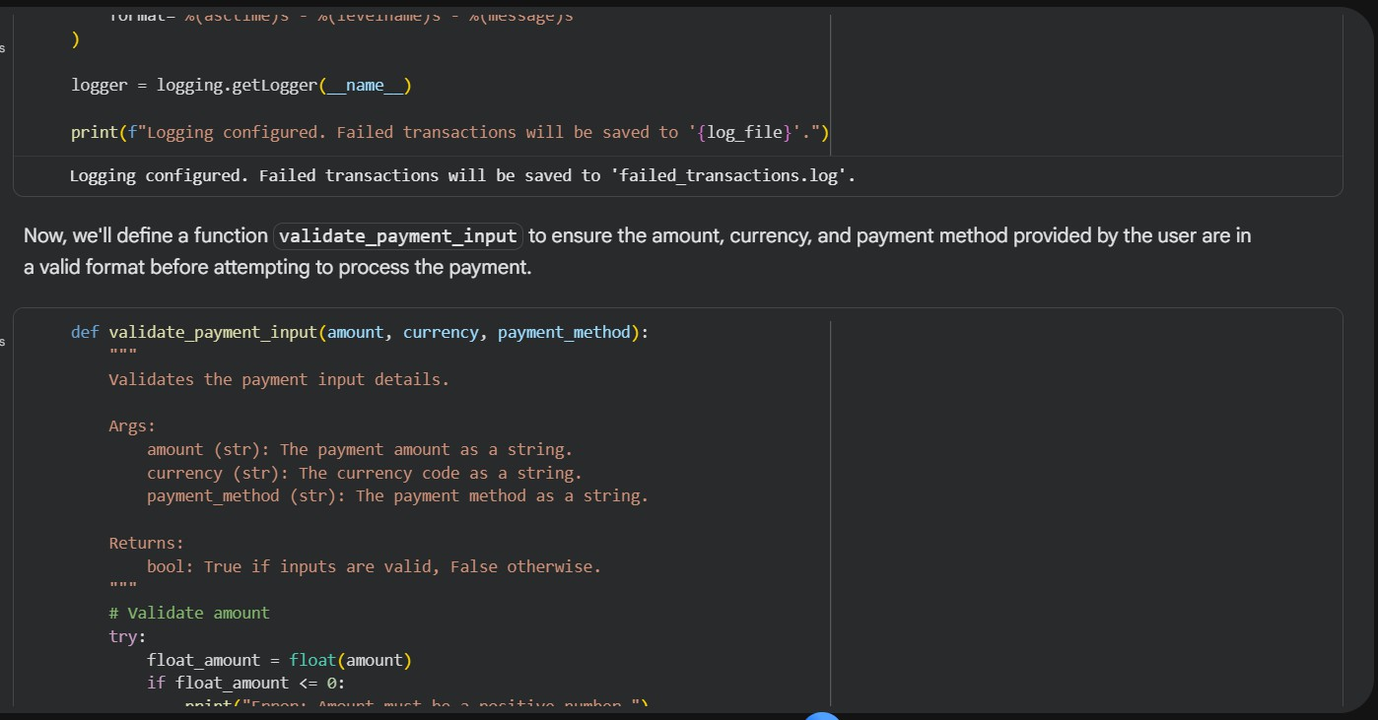
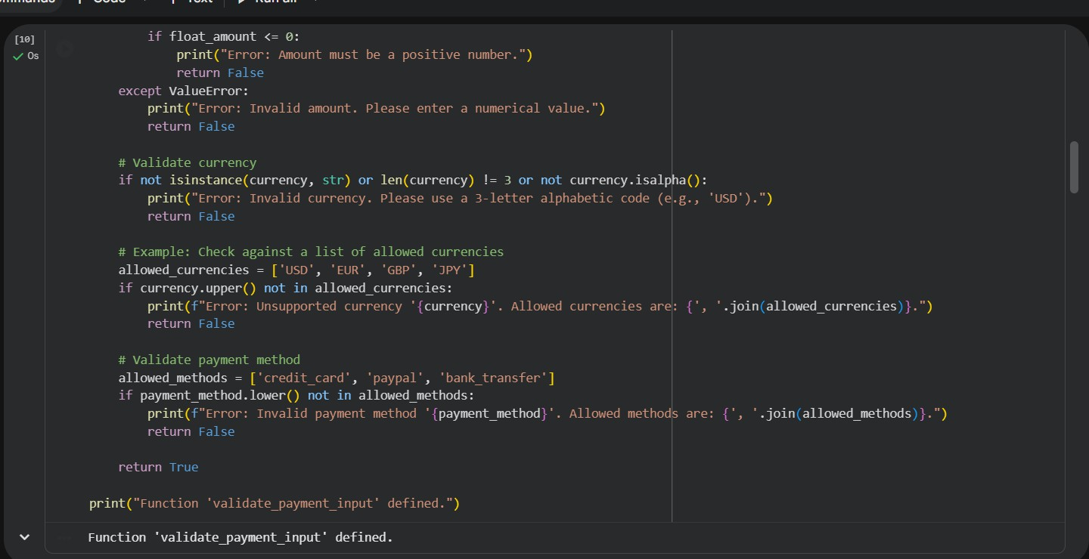

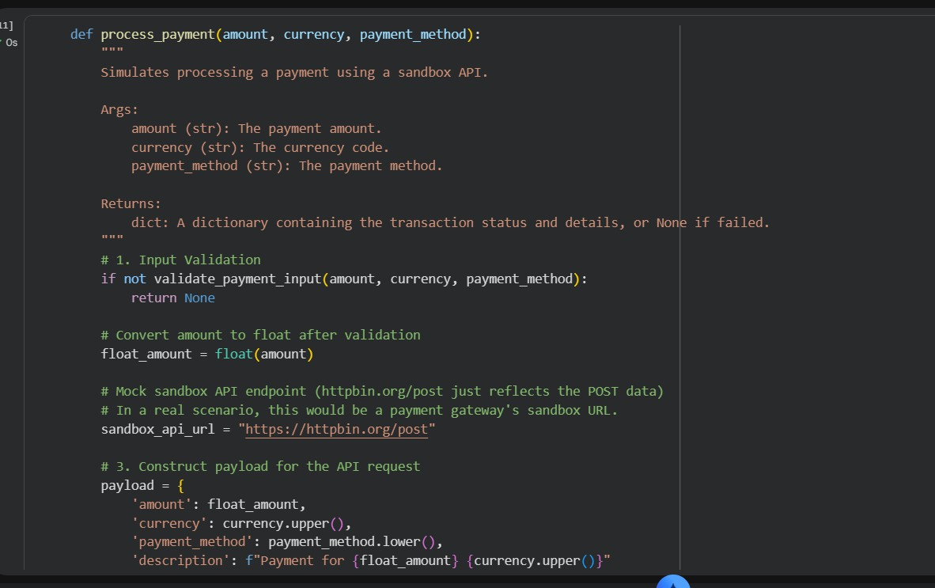
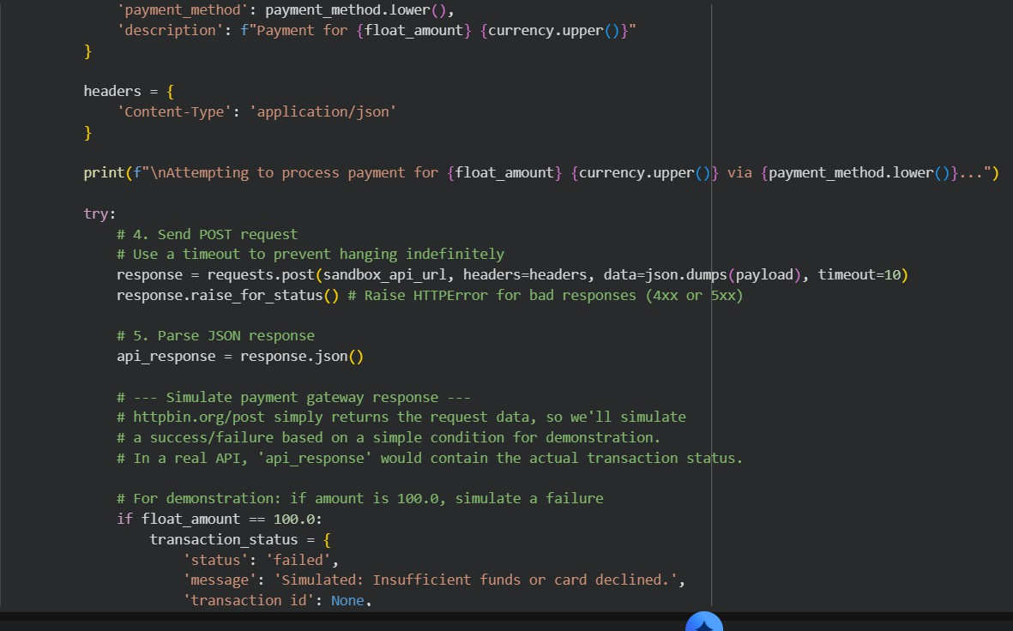

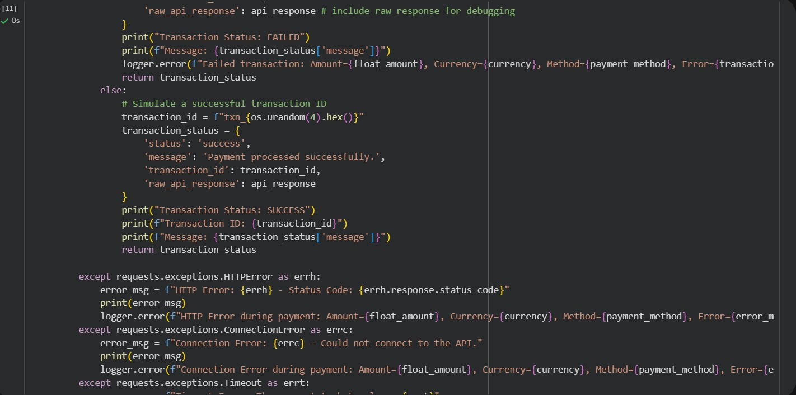
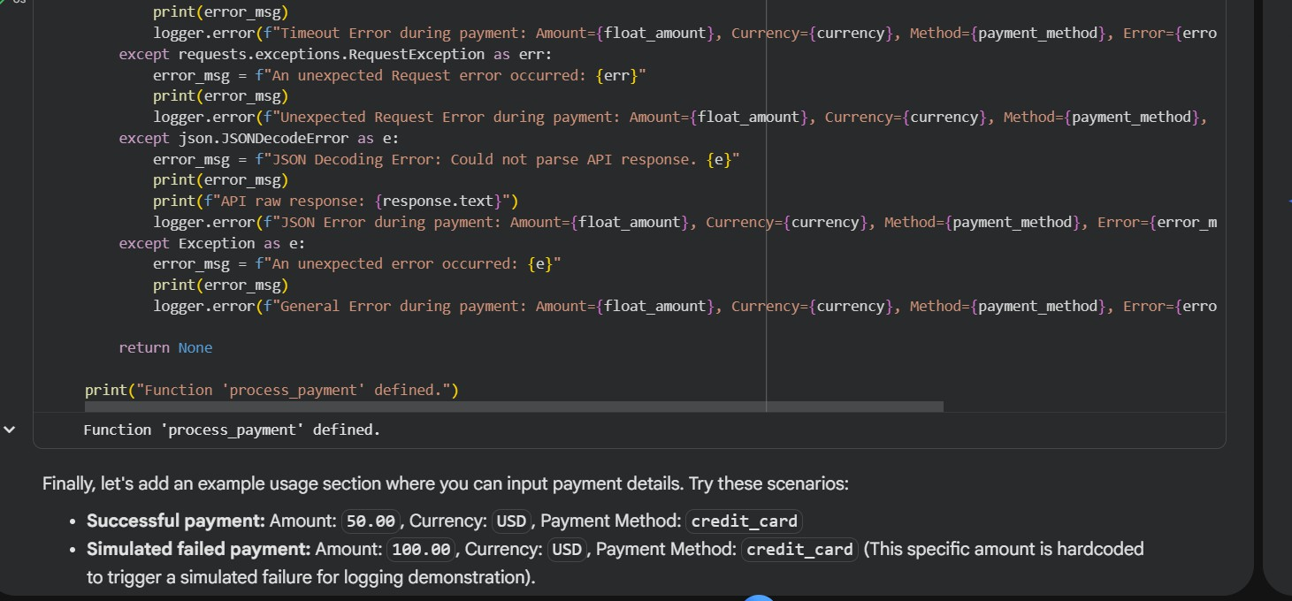
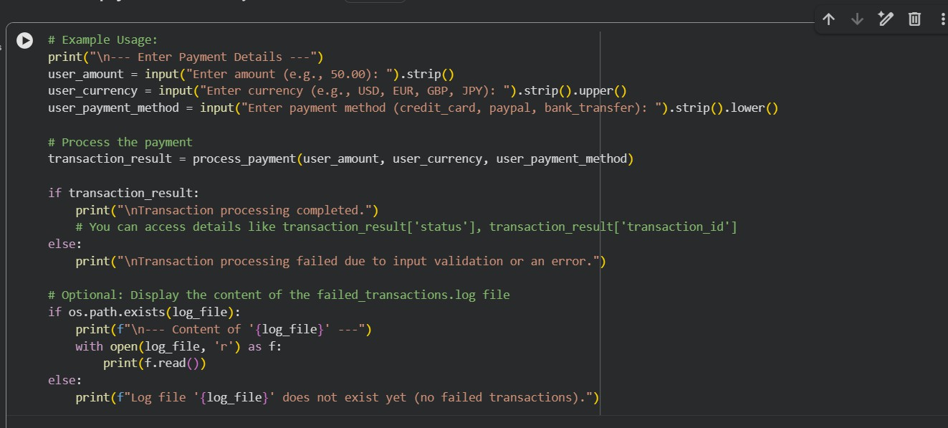

Output :
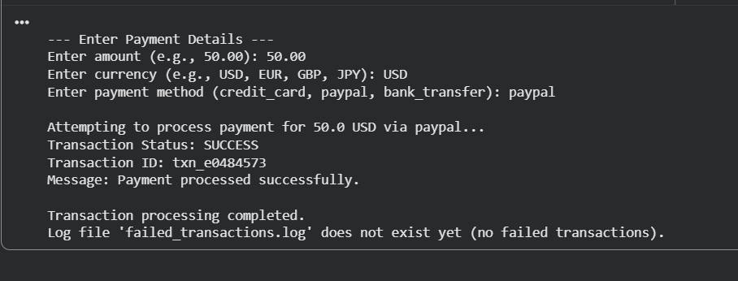
Explanation : This script sends payment details (amount, currency, method) to a sandbox API, checks if inputs are valid, and processes the transaction. It handles errors like invalid data, server issues, or network failures, shows the payment status, and logs failed transactions to a file.

